14th Media Forum
in the framework of
the 35th Moscow International Film Festival

presents

Special project by Milica Tomić
in the framework of
lecture programme Mocumentary: Reality Is Not Enough

Organized by “Mediafest”, Cultural and Research Centre “MediaArtLab”, Moscow Museum of Contemporary Art.
Co-Organizer: Museum Exhibition Complex "Manege".
Venue: Open School "Manege/MediaArtLab" in Central Exhibition Hall Manege (Manezhnaya square, 1)
Workshop dates: 21 — 24 June 2013.
Partners of the project: Goethe-Institut in Moscow, The Embassy of Israel in Moscow, "PRO HELVETIA" Foundation, The Embassy of France in Moscow, Triumph Gallery.
Media Forum curator: Olga Shishko. Media Forum producer: Elena Rumyantseva.

One of the main events of the lecture programme in the framework of the 14th MIFF Media Forum Mocumentary: Reality Is Not Enough is the arrival of one of the most popular contemporary political artists — Serbian video artist Milica Tomić with her workshop programme. Milica Tomić is coming to Moscow to create a new part of her ongoing project Container as well as to give a workshop for the students of Open School "Manege/MediaArtLab". The reconstruction of Container which will take place in Moscow is going to reflect Milica Tomić's views on the relationship between history and art — whether it is worth combining personal and political aspects in art, which methods help an artist to rethink and treat the history, the mechanisms of commenting on political consciousness in art and the way art can influence it.

Milica Tomić was born in 1960 in Yugoslavia. Since 90s, at the early age of her career in fine arts, Milica Tomić has raised the questions concerning national identity and historic memory in her works. Her method is mainly based on the research of breaking points in the fates of definite people and nations. The ground for her extensive work with video is always formed according to a deep research and intense reflection. In I Am Milica Tomić (1999) — one of her best-known videos — the artist pronounces the phrase “I am Milica Tomić” in different languages after which her body covers with deep bloody stigmata. The idea of this work is that we are born without right of choice — obtaining a name and nationality we also inherit historical memory of our ancestors, public past, sore spots, and hurt which were left on the bodies and in the memory of people from the previous generations.

Milica Tomić comes to Moscow with her ongoing project Container (first was shown in 2004) where historical evidence, political statements, and artistic reconstruction are connected together once again. The theme of the exhibition and lecture programme Mocumentary: Reality Is Not Enough gets new edges in her work: Milica Tomić screens the scene of human tragedy and war crime which evidence was hushed up for the sake of political interests.

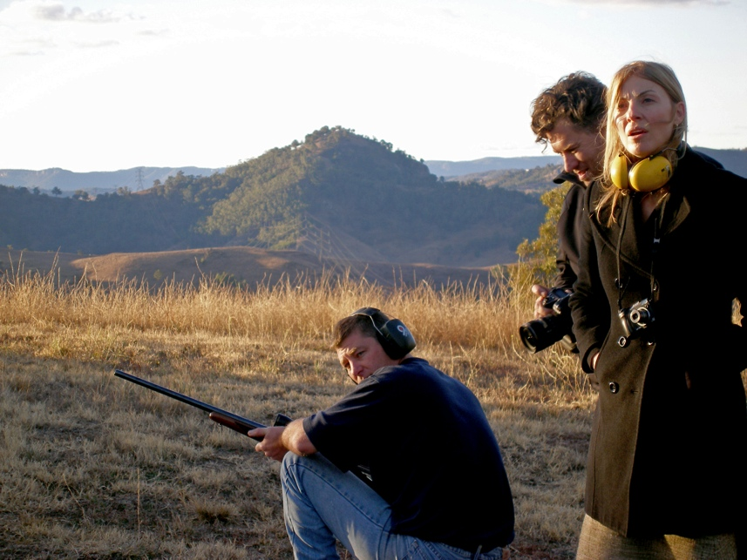

Records of Container reconstruction. Courtesy of the artist.

The starting point for the thoughts for this work was war crime — tragic Taliban massacre in Afghanistan in 2001. In northern Afghanistan, in Mazar-i-Sharif, more than a thousand of participants of Taliban movement succumbed to American troops and thereafter they were placed into cargo containers and kept in a desert without water and food. When the majority of captured began to die of suffocation and asked for fresh air, American army troops decided to provide air through the scars of bullets. For that aim they fired the container point-blank. All captured died of thirst, suffocation, or mass execution, but there were no official documents or visual evidence of this act left. As in many other cases of military offence all the facts, responsible executives, and the causes of the decisions taken in Mazar-i-Sharif remained in the shade — the history was buried.

Milica Tomić, who had constantly reflected on the subject of the civil war in Yugoslavia, militarism, and violence in crisis spots, decided to use evidence from northern Afghanistan to recreate lost scene of military tragedy and unprecedented inhumanity. In Container she deconstructs the war turning it from a long-ago media event into an audiovisual experience.

Moscow will become a new place for the Container reconstruction: students from Open School "Manege/MediaArtLab" with Milica Tomić will come to the shooting range and will shoot a container with the Kalashnikov gun under her supervision. Later the shot-out container and documentation of this reconstruction in video format will be shown in the frame of exhibition Mocumentary: Reality Is Not Enough in the MIFF. The exhibition will present other archive materials of the project that were earlier realized by the artist in Serbia, Bosnia, Australia, Great Britain, and Armenia. The reconstruction of the Container as a part of the exhibition and lecture programme Mocumentary: Reality Is Not Enough will demonstrate Milica Tomić's view on political art in the reality of the 21st century, and also on the reconstruction of lost or forgotten on purpose evidence of human violence by means of facts and fiction.

Attention! To attend lectures by Media Forum pre-registration is required http://mediaartlab.timepad.ru/events/

More information on the event:
http://mediaforum.mediaartlab.ru/

Contact for the press:
Selena Volkonskaya, s.volkonskaya@mediaartlab.ru,
+7 905 574 11 00

Contact for the lecture programme:
Olga Lukyanova, lukyanolga@gmail.com,
+7 905 506 60 53

