14th Media Forum in the framework of
the 35th Moscow International Film Festival
presents

Expanded Cinema 3 — Mocumentary: Reality Is Not Enough

The exhibition is organized by “Mediafest”, Cultural and Research Centre “MediaArtLab”, Moscow Museum of Contemporary Art.
Co-Organizer: Museum Exhibition Complex "Manege".
Venue: Moscow Museum of Modern Art (Gogolevsky Boulevard, 10)
Exhibition dates: 25 June — 26 July 2013. Opening for press — 24 June 2013.
Participants: Harun Farocki (Germany), Omer Fast (Israel), Milica Tomić (Serbia), Monica Studer and Christoph van den Berg (Switzerland), Walid Ra'ad/ The Atlas Group (USA—Lebanon), Janez Janša, Janez Janša, Janez Janša (Slovenia), Nonny de la Peña and Peggy Weil (USA), Dimitri Venkov (Russia), Dina Karaman (Russia), Roman Mokrov and Sergey Muravyev (Russia), Jack and Leigh Ruby (Australia), Ranbir Kaleka (India), Vladimir Arkhipov (Russia), Nikolay Onishchenko (Russia), Elena Gorbacheva (Russia).
Lecture Programme Venue: Open School "Manege/MediaArtLab" in Central Exhibition Hall Manege (Manezhnaya square, 1)
Lecture Programme Dates: 21 — 26 June 2013.
Lecture Programme includes open lections and workshops by the following artists: Omer Fast, Monica Studer and Christof van den Berg, Milica Tomić, Nonny de la Peña and Peggy Weil, Manuela Morgaine, Janez Janša.
Partners of the project: Goethe-Institut in Moscow, The Embassy of Israel in Moscow, "PRO HELVETIA" Foundation, The Embassy of France in Moscow, Triumph Gallery.
Exhibition curator: Olga Shishko (art director of the MIFF Media Forum, director of the Open School Manege/MediaArtLab). Exhibition director: Elena Rumyantseva (programme director of the MIFF Media Forum).
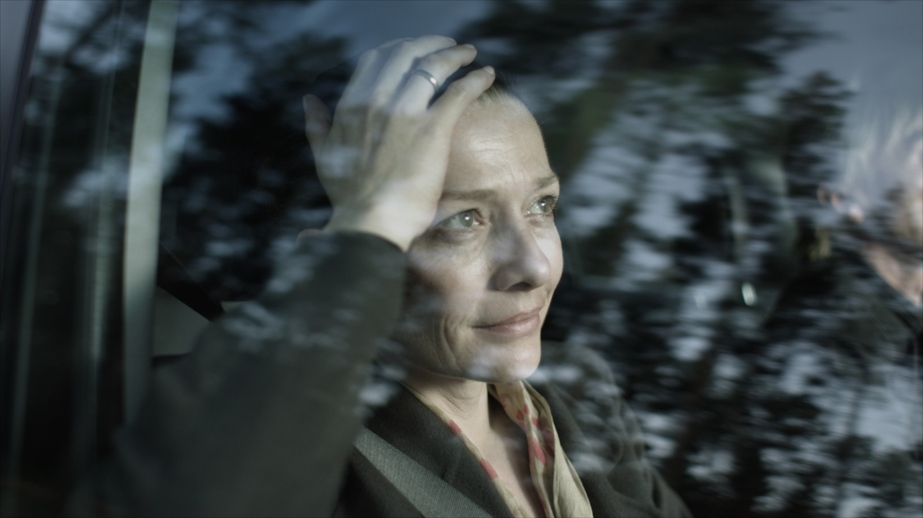
Fragment of work “Continuity” (2012) by Omer Fast. Courtesy of the artist. Arratia Beer, Berlin; gb agency, Paris. Commissioned by dOCUMENTA (13) and Thyssen-Bornemisza Art Contemporary, Vienna, with the support of 3sat, Medienboard Berlin-Brandenburg GmbH, Berlin, and OK Offenes Kulturhaus Oberösterreich. Produced by Filmgalerie 451, Berlin

The third installment in the MIFF Media Forum Expanded Cinema series — Mocumentary: Reality Is Not Enough presents the cutting-edge selection of contemporary art works in the genre formed in-between cinema, video and media art. The exposition curated by Olga Shishko (art director of the MIFF Moscow Media Forum) is compiled of the masterpieces of the modern artists from Russia and abroad, utilizing pseudo documentary and mocumentary strategies in their creative practices. Mocumentary: Reality Is Not Enough poses the question of blurred borders between fiction and reality in the era of media addiction, infoglut and uncritical consumption of data and images.
Mocumentary, a genre long-established and well-known to the audience, gathers significant attention among contemporary artists as an active critical strategy. It first appeared in cinema more than 50 years ago as a complete fiction made in accordance to the documentary rules and complies with the parameters of the quality historical evidence. Just as a well made documentary film, a work of mocumentary contains a story supported by facts, witness interviews, play-by-play recordings, material evidence and expert opinions. But in contrast to the qualitative documentary study, mocumentary replaces all the elements of the narrative with false or parody to create a comic effect and becomes a false story from the beginning to the end — events that never happened, fraudulent facts, fake experts and counterfeit records.
Mocumentary: Reality Is Not Enough focuses on the application of the mocumentary practices both as a creative technique and as means to make an artistic statement. In contemporary art the genre provides an opportunity to question the truth behind the visible and the transmitted and to deconstruct established historical paradigms. With the help of fakes and simulations modern artists play out the wide-spread myths, false stereotypes and generally accepted facts. The main goal of the experiment is the audience self-criticizing, propaganda and disinformation in media, the niceties of the social contract and painful historical experience.
All artists presented in the framework of the Mocumentary: Reality Is Not Enough exhibition work with imperceptible transition from reality to its distorted reflection in the age of television boom, media consumption, and the growing passivity of the audience in fact analysis. They represent a critical overview and an active political position, creating the new legends by means of video, editing, special effects, and dramatizations. And they can turn all the tricks of the documentary into a no-lose weapon of art play for rewriting history, exposing the complexes and defining pain thresholds of individuals, society, eras and nations. Mocumentary: Reality Is Not Enough displays the cutting-edge contemporary art research in the man's place in history, the substitution of reality by skillfully crafted illusions and the boundaries between the historical and political statement.

Participants of Mocumentary: Reality Is Not Enough
German documentary filmmaker Harun Farocki will present in Moscow his sensational project previously exhibited in MoMA — Serious Games. He focuses his study on computer games, strategic simulators used in the U.S. military combat training and PSD psychological rehabilitation. The main Farocki’s interests in this documentary research are the absolute imbeddability of adults in the virtual world, and the dual nature of the world which, on the one hand, prepares people to the horrors of war, and, on the other hand, purges them.
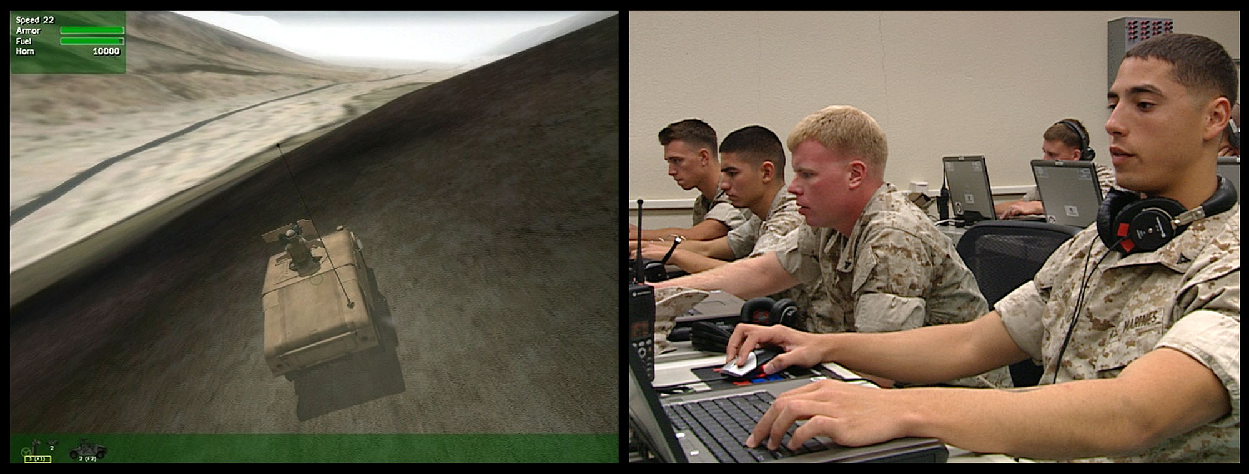
Fragment of the Harun Farocki’s work “Serious Games” (2010-2011). Courtesy of the artist.
Serbian video artist Milica Tomić recreates the image of a non-existent incident of a war crime in her work Container. The subject of her work was the Taliban massacre in northern Afghanistan in 2001, when thousands of troops from the Afghan side were placed in cargo containers and died of thirst, suffocation, injury or mass execution. Milica Tomić recreates the scene of the crime, traveling across the continents with the container and placing in it the victims of murder or tragedy — those who perished from the earthquake in Armenia, or the civil war in Yugoslavia. Every time the artist makes a dramatization according to the accurate data of weapons, shooting techniques and the number of victims found in the place of Afghan disaster. In Russia she will continue the Container project by working on it with the students of the Open School Manege/MediaArtLab.
Swiss artistic duo of Monica Studer and Christoph van den Berg creates an illusory reality, collecting the real pictures, collective memory, nostalgia and the dream of a perfect holiday in the Alps. Their online project and installation Mountain Top is a paradise 3D-holiday one can reach in the Internet, exploring idyllic Alpine landscapes, interiors and coordinates by clicking the mouse. Parodying the narrow-minded aspirations and tourism advertising, artists speak of the consumption as primarily of an acute desire for unique experiences.
Continuity, a forty-minute film by German-Israeli artist Omer Fast, was one of the highlights of the dOCUMENTA exhibition last year in Kassel. Omer Fast works with the theme of gain and loss, recreating unrealistic scenarios of the only son’s return from the war in Afghanistan. The role of the deceased son was performed by hired boys, doing it each in their own way and giving parents the emotions of convergence and estrangement, both sexual and psychological. Artist is interested in trauma and the healing effect of its constant repetition as one of the main attributes of human affection.
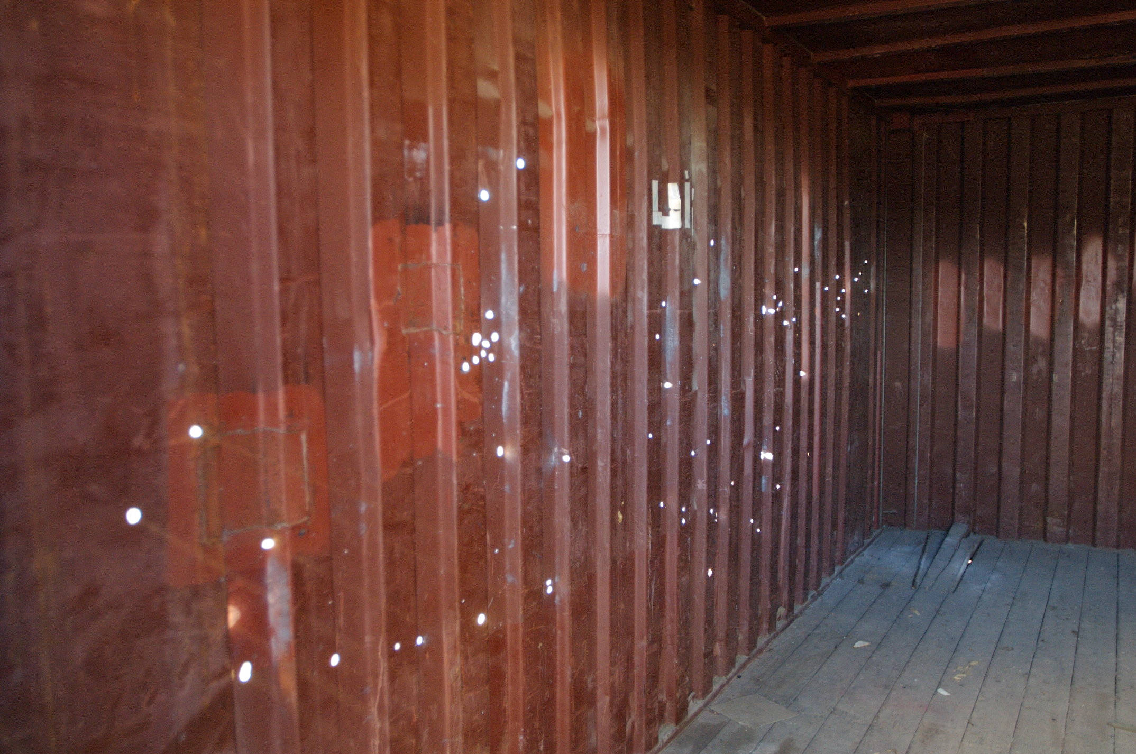
The Milica Tomic’s work “Container” (2004 — present). Courtesy of the artist.
The Atlas Group, a fictional organization of the US-Lebanese artist Walid Ra'ad, is an alternative view on Lebanon modern history which is hushed up for the sake of political propaganda and state. In the video Hostage/ The Bachar Tapes Ra'ad gives the floor to the Lebanese prisoner Souheil Bachar who spent three months in captivity along with the U.S. troops, whose capture sparked a major military scandal between Iran and the United States.
Whether the identity can be defined by official documents or simulations can change the personality — this theme is observed in the work Name Ready Made by three artists of the same name — Janez Janša. In 2007 with a common agreement three international artists — Žiga Kariž from Slovenia, Emil Hrvatin from Croatia and Davide Grassi — changed their name for the name of Slovenian Prime minister Janez Janša. Using avant-garde practices with readymades invented by Marcel Duchamp the artists will present original official papers and create a new work especially for Moscow exhibition.

Having studied the web simulators, the American artists Nonny de la Peña and Peggy Weil created the Gone Gitmo online project — a recreation of Guantanamo prison in an alternative online game universe. They invite everyone to experience the situation at Guantanamo from within a model of the prison and witness prisoner's lack of access to basic habeas rights. For over a decade de la Peña and Weil have been studying the growth in potential of online and digital media, games and data visualization, including the line between hoax and history and the possibility of feeling empathy from immersion into the non-fiction stories.

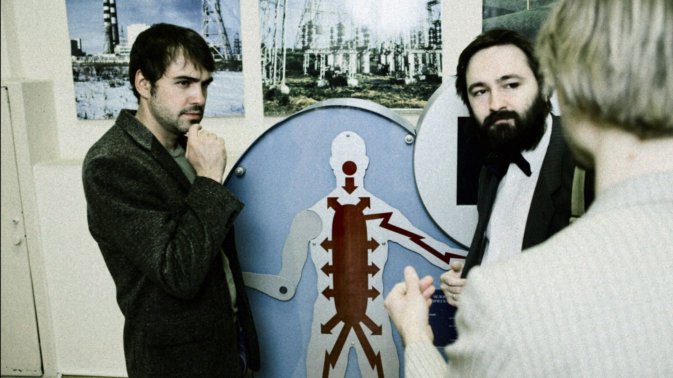
Fragment from Dmitry Venkov’s work “Chinese Room of Alan Turing” (2011). Courtesy of the artist.
Russian artist Dimitri Venkov actively works in the mocumentary genre and is primarily interested in the ambivalence of the documentary concept and the use of information as means of deception, media delusion and manipulation. His work America ​​is a witty fiction, making fun of the cinema research on the role of the dairy industry in the Second World War victory. His Chinese Room of Alan Turing there tells about an imaginary mad cybernetics explorer and his scientific experiments in the Soviet era. By weaving into his works the conspiracy theories, Cold War paranoia and settling historical scores, the artist is trying to understand the nature of the false fact interpretation and meta myths creation.
Video installation Cognitive Broadcast created by the Russian artist Dina Karaman works with the problems of popular science as a symbol of progress, the Soviet myths about the all-powerful science as part of the just world order in socialist model. Dina examines how patchy experiment and research data takes the form of reliable knowledge, trustworthy dialogue and progressive paradigm inspired by the immense legacy of Soviet science and technology broadcasts.
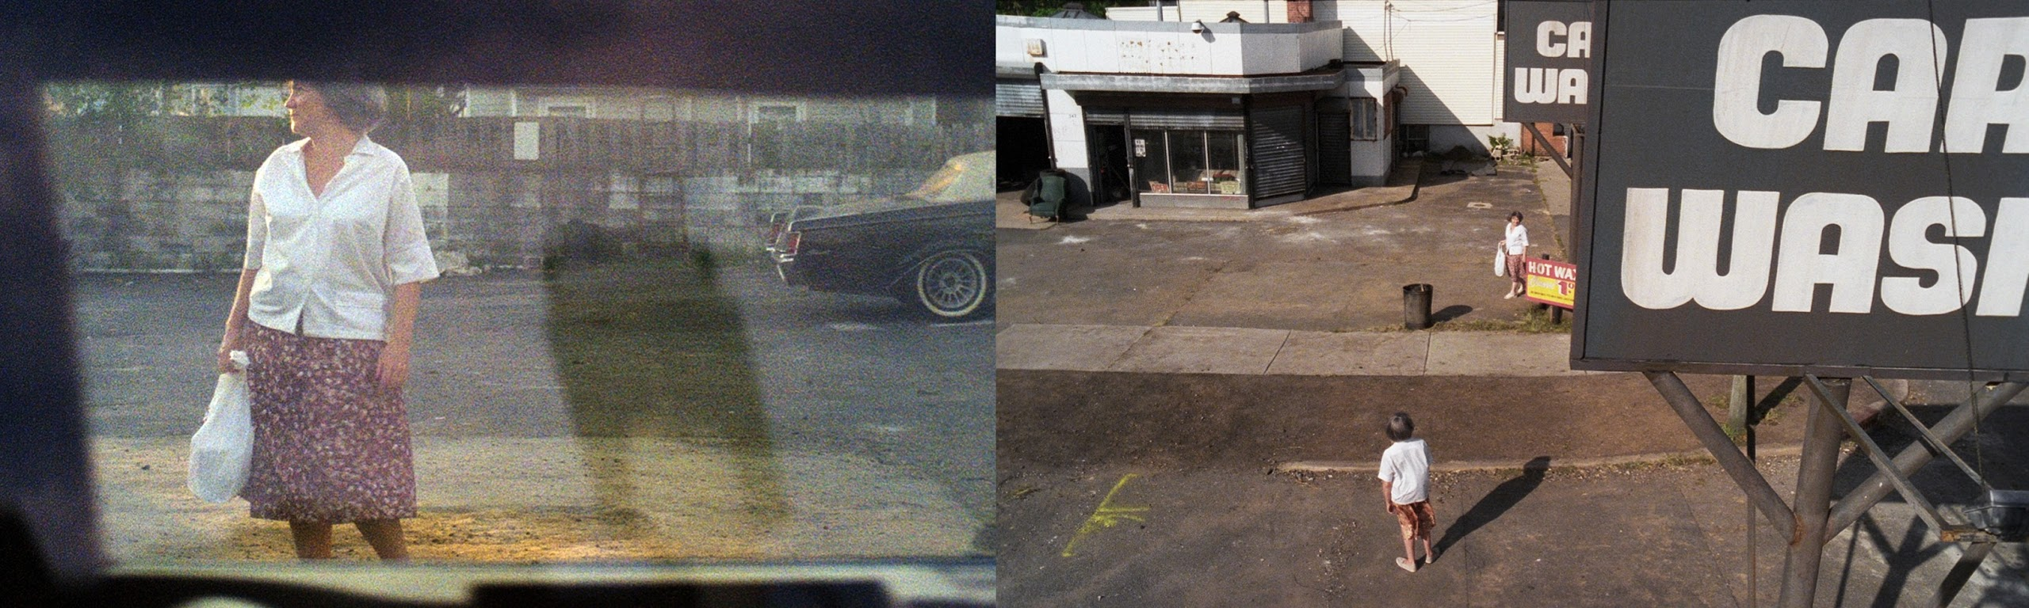
Fragment of the Jack and Leigh Ruby’s installation “Car Wash Incident” (2012). Courtesy of the artist.

The work House of Opaque Water by Ranbir Kaleka, an Indian painter and video artist, contains the interlacement of a real story about disappearance of people’s settlements under the water and staged poetization of a future flood. Kaleka makes up a set of videos of disaster, both inevitable and beautiful in its totality, by applying rich imagery of South Asian tradition. The strand of the narrative is proceeded from the memories, prevision, and reveries of an old man who will soon find his asylum in a house of opaque water.
Russian artist Vladimir Arkhipov in his series Accidental Traces of Homemade Objects describes unintentional and found art which leaves marks on the working process of the artist. For many years Vladimir Arkhipov has been successively searching and collecting homemade objects of non-artistic origin for utilitarian function. During the process of documentation and taking photos they leave faint and inadvertent traces on a piece of flizelin — a universal material for the background which the artist takes everywhere he goes and seeks for a new homemade object.
Experiments with human imagination, visual and artificial perception make up a body of the project Impossible Landscapes by Nikolay Onishchenko. A person while looking at abstract forms identifies them with some landscapes that haven’t been created by the artist on purpose. But the viewer sees them due to his previous visual experience and personal imagination. This fiction based on the real document emerges in consciousness right in the moment of looking at the object.
Russian photographer and media artist Roman Mokrov tells about the phenomenon of absurd in Russian reality and investigates symbolic field and mythology of “non-Moscow”, small provincial or regional towns, in search of intangible contemporary identity. In his work Homewards in collaboration with Sergey Muravyev two young guys are riding in a rubber boat from one village into the other recreating their parents' everyday experience. This video poses the question whether it is possible to repeat the history many years on, shows the process of such reconstruction, and reflects on what this journey has to do with history, myths, and reality.

Lecture programme and screenings in the frameworks of
Mocumentary: Reality Is Not Enough
Besides the exhibition, the 2013 Media Forum programme includes a series of lectures and workshops by Mocumentary: Reality Is Not Enough artists. The lecture programme of Media Forum-2013 is not only an opportunity to learn about the development of mocumentary as an active artistic strategy, but also direct collaboration with the leading contemporary artists who create the alternative reality of pseudo documentary.

Seven of project’s participants will come to Moscow to meet the audience in person and give practical advice to young artists. They are: the creator of one of the most profound works of past dOCUMENTA(13) Omer Fast, authors of simulacres in the web and reality Monica Studer and Christoph van den Berg, political artist Milica Tomić, online experimenters Nonny de la Peña and Peggy Weil, and Italian performance artist Janez Janša. Specially for the exhibition artist Milica Tomić will create a spectacular reconstruction of her war crime work Container, goint to a shooting range with students of Open School Manege/MediaArtLab. The container shot at close range with AK-47 and the documentation of the process will be presented at the exhibition Mocumentary: Reality Is Not Enough.

The lecture programme of the event also contains a cinema retrospective, collected from the mocumentary-related works by contemporary artists who are not present at the exhibition.

Media Forum opening will be supported by a mocumentary premiere Lightning directed bу a remarkable star of European independent cinema — French filmmaker Manuela Morgaine. Her movie was one of the main revelations during the past Rotterdam Film Festival. An epic four-hour work Lightning (2012) is an extended meditative fantasy told via mosaic of images and memories of different people from different eras. The film consists of four seasons and involves the spectator into metaphorical change of seasons, various situations, and mythological systems where the actors recreate their experience – the feeling of a thunder stroke and human insecurity in the face of nature. A thunder stroke, as transcendental experience, is shown in a form of a journey through time and space surrounded by made up stories, world legends, and esoteric practices. They all dissolve the actors in absolute and make them closer to the sensual perception of the order of things.
The boundary between publicity, paranoia, and personal identity is being scrutinized by three artists from Slovenia, Italy, and Croatia who in 2007 changed their names for that of the stirring Slovenian politician — the Prime Minister Janez Janša. In their documentary My Name Is Janez Janša (2012) they discuss how the life changes when one arrogates the name of one of the most important people in the country, what happens to the identity and whether it is a political or artistic gesture.
The Falls (1980) is the first feature film and curious research in the genre of mocumentary by British film director and video artist Peter Greenaway. Fictional actors of The Falls with the help of their stories, dramatization, and dialogues reconstruct Violent Unknown Event that happened to them. The veil lifts a bit in this ironic film which is a parody on traditional methods of documentary and non-fiction filmmaking. As in an ordinary documentary, for instance, by British broadcasters, the story is made up from counterfeit evidence, opinions of non-existing experts, and reconstruction of non-happened events.
Werner Herzog, a German film director who is famous for his courageous experiments on the edge of documentary and fiction, creates in his Lessons of Darkness (1992) a fiction on catastrophe in the Persian Gulf based on his real shots. The film by Werner Herzog is free of speaking actors, there is only an off-screen voice of the director who comments on the scene of dissolution, darkness, and harm caused by humanity. Werner Herzog in his one-hour mocumentary raises the following questions — how a part of nature may be the source of danger for this nature, and where is the origin of deconstruction and people’s desire for violence.

Mocumentary: Reality Is Not Enough experience will be enhanced by the exhibition catalogue with a collection of analytical essays by world experts, curators and critics, as well as in-depth interviews, unique illustrative materials and study of creative practices of the contemporary artists who chose the work at the intersection of documentary, fiction and creative play as their method.

More information on the exhibition:
http://mediaforum.mediaartlab.ru/

Contact for the press:
Selena Volkonskaya, s.volkonskaya@mediaartlab.ru,
+7 905 574 11 00

Contact for the lecture programme:
Olga Lukyanova, lukyanolga@gmail.com,
+7 905 506 60 53

